Experiment no.: 08
Title: Filter packets according to protocol using any packet filtering tool.
Course Outcome: Build systems that are more secure against attacks.
Theory:
Packet filtering is a fundamental concept in computer networking and network security. It involves monitoring and controlling network data packets based on predefined rules or protocols such as TCP, UDP, ICMP, or HTTP. Each packet contains header information, including source and destination addresses, ports, and the communication protocol used.
When filtering packets according to protocol, a firewall or network analyzer inspects each packet and allows or blocks it depending on the specified protocol type. For example, a rule may allow only TCP packets and block UDP or ICMP packets. This process helps in managing network traffic, enhancing security, and preventing unauthorized access or attacks.
Tool used: Wireshark
Wireshark is a popular open-source network protocol analyzer used to capture and examine data packets traveling across a network. It helps in understanding how network protocols work, identifying network problems, and ensuring secure communication.
By using packet filtering in Wireshark, users can view packets of a specific protocol (like TCP, UDP, ICMP, or HTTP), which makes analysis easier and more focused.

Concept
Every data packet transmitted over a network contains header information, which includes the protocol type used for communication.
Wireshark allows users to apply display filters to show only packets matching a specific protocol or condition.
For example:
- tcp → Displays only TCP packets
- udp → Displays only UDP packets
- icmp → Displays only ping (Internet Control Message Protocol) packets
- http → Displays only web traffic packets
This helps in analyzing how specific protocols behave and interact within the network.

Applications
- Network Troubleshooting – Helps identify network issues like delay or packet loss.
- Security Monitoring – Detects suspicious or unauthorized network activities.
- Performance Analysis – Analyzes traffic patterns and data flow efficiency.
- Educational Use – Demonstrates how protocols like TCP, UDP, and HTTP work.

Advantages
- Real-Time Monitoring – Captures live network traffic instantly.
- Detailed Packet Information – Displays in-depth protocol-level data.
- Protocol-Specific Filtering – Simplifies analysis using filter expressions.
- Free and Open Source – Available for all major operating systems.

Limitations
- Complex for Beginners – Requires understanding of network protocols.
- High Data Volume – Capturing large traffic can slow down the system.
- Limited Access on Encrypted Traffic – Cannot read encrypted HTTPS data.
- Administrative Privileges Required – Needs elevated permissions to capture packets.
Steps:
- Install Wireshark – Download and install Wireshark along with WinPcap/Npcap.
- Open Wireshark – Launch the application to access the main interface.
- Select Network Interface – Choose the network (Wi-Fi or Ethernet) to capture packets.
- Start Packet Capture – Begin capturing live network traffic.
- Apply Protocol Filter – Enter the desired protocol (e.g., TCP, UDP, ICMP) in the filter bar.
- Analyze the Packets – View details like source, destination, ports, and data of filtered packets.
- Stop the Capture – End the packet capture after collecting sufficient data.
- Save or Export Results – Save the captured or filtered packets for future analysis.
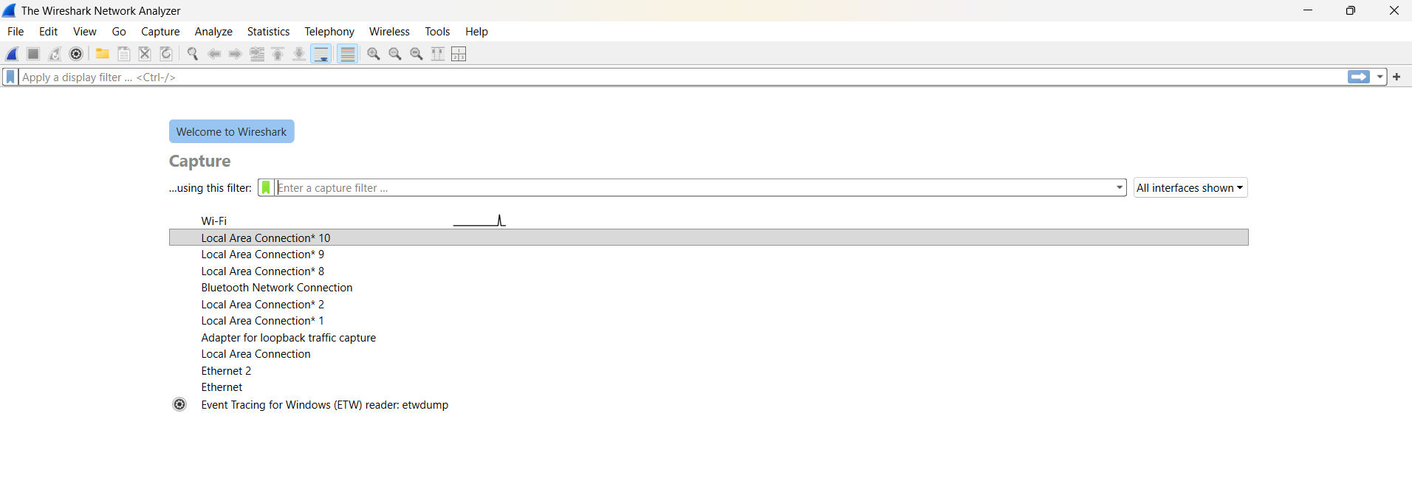

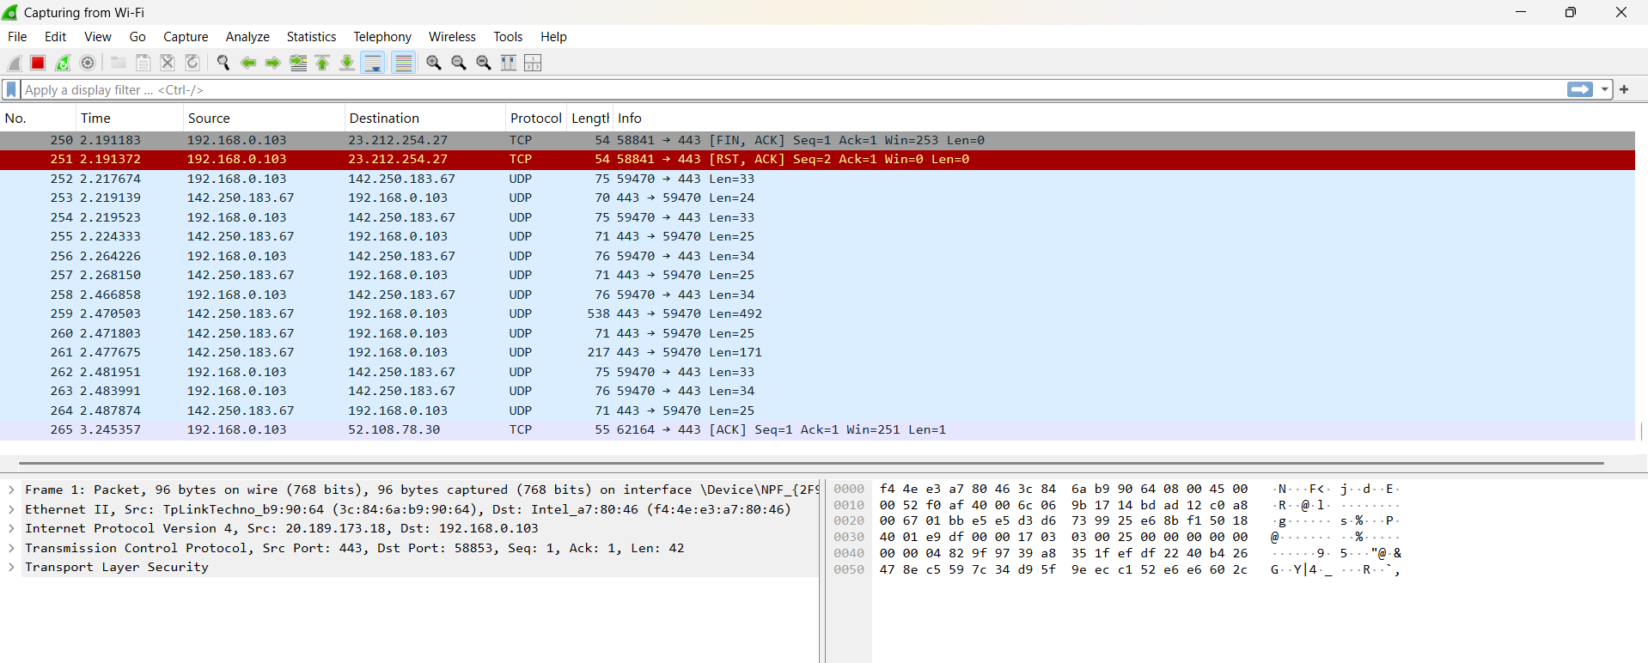
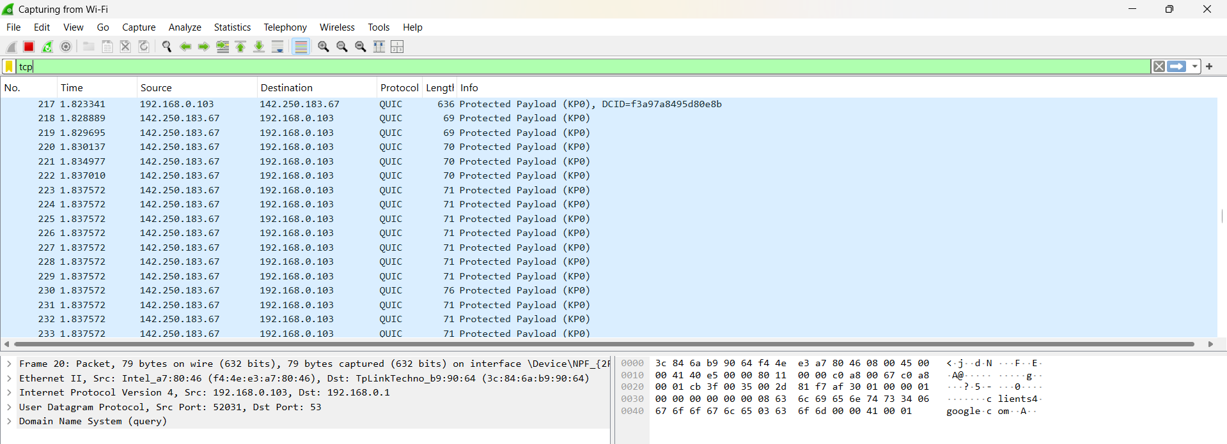

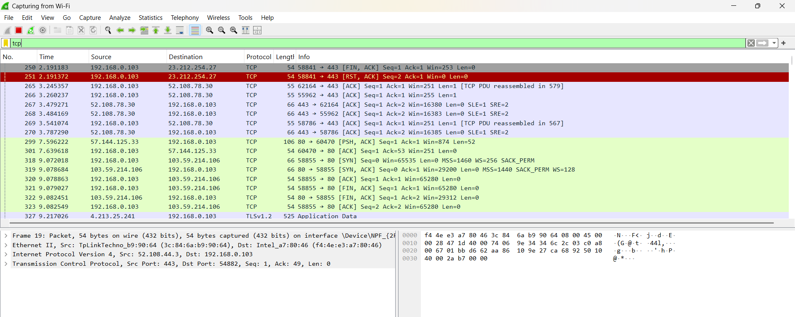

Conclusion:
I have successfully learned packet filtering using Wireshark.

